Bacterial Diseases of Crucifers

The Economic Threshold Level (ETL) for crucifers also known as brassica leafy greens is low, as growers depend on the foliar health & quality of these crops for wholesale. Plant pathogenic bacteria threaten the foliar health of these leafy greens and have become a significant limitation of production in recent years.

Common Bacterial Diseases & Casual Agents

Bacterial blight, Pseudomonas cannabina pv. alisalensis
Leaf spot or pepper spot, Pseudomonas syringae pv. maculicola
Black rot, Xanthomonas campestris pv. campestris

These pathogens can enter the host plants through insect or mechanical wounds and natural leaf openings, often reaching plants through irrigation or splashing rain. The pathogens survive in the soil and infected plant debris, so plantings in fallow fields are at risk of re-infection.

Hosts

These bacterial pathogens have a combined wide range of brassica hosts (arugula, broccoli, radish, turnip, cabbages, collards, mustards, bok choy, kale, cauliflower, etc.), but individually may not be pathogenic on each of these hosts. Examples of disease:
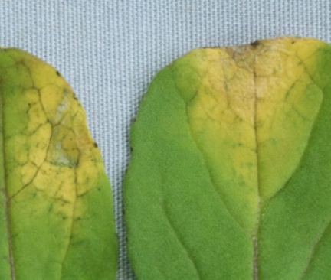

Photo Credit Carolee Bull
Photo Credit Steve Koike​
Photo Credit Carolee Bull
Bacterial blight, (P. cannabina pv. alisalensis) on arugula can be identified by small chlorotic-bordered lesions that spread quickly.
Pepper Spot, (P. syringae pv. maculicola) looks as though somebody sprinkled table-pepper on leaves.
Black rot (X. campestris pv. campestris) is recognized by a V-shaped lesion originating at the leaf margin.

Management Strategies

Crop rotations with non-hosts can reduce holdover inoculum from an infected crop to the next. Plant spacing may help reduce humidity and spread of the pathogen. The pathogens are seedborne and planting high quality seed is recommended.

Our Goal

There has been significant loss of arugula due to bacterial blight in the northeast in recent years. The NorthEast Arugula Team (NEAT) was formed in response to grower inquiries raising concerns over bacterial diseases on their brassica leafy greens. Our goal is to identify bacterial pathogens causing diseases on arugula and other brassica leafy greens, design effective management strategies and spread the information to growers.

Our Team

NEAT is a collaborative effort between The Pennsylvania State University (Carolee Bull & Cameron Cedeno), Cornell University (Elisabeth Hodgdon), University of New Hampshire (Rebecca Sideman), and University of Vermont (Ann Hazelrigg). NEAT is advised by a committee of farmers, developers, and plant breeders. NEAT receives funding through the NE SARE Project LNE23-463.

Bull, Penn State University: https://plantpath.psu.edu/research/labs/bull
Hodgdon, Cornell University: https://cals.cornell.edu/elisabeth-hodgdon
Sideman, University of New Hampshire: https://colsa.unh.edu/person/rebecca-sideman
Hazelrigg, University of Vermont: https://www.uvm.edu/cals/pss/profiles/extension-associate-professor-ann-hazelrigg
NEAT NE SARE page: https://projects.sare.org/sare_project/lne23-463/

Sending Samples/Scheduling a Farm Visit

If you’re interested in having your crops surveyed and pathogens identified, please contact Cameron Cedeno by email cjc315@psu.edu, or phone 724-732-2238.

